

**SPORTS, HEALTH & WELLBEING**

**ACTIVITY DETAILS**

Wellbeing Group

**HEADWAY HOUSE**

**Moseley Hall Hospital**

**Alcester Road, Moseley, B13 8JL**

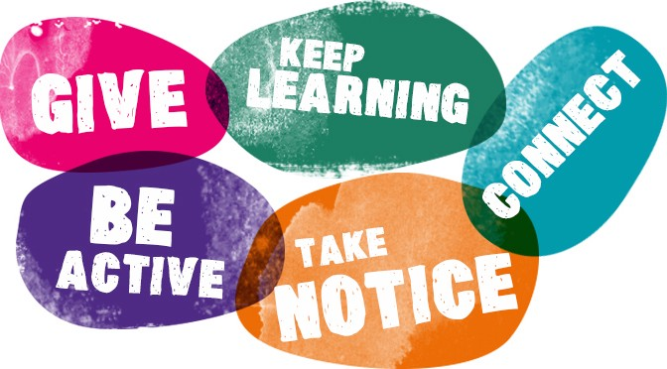

**COST**

£3 per person

**TIMES**

 Once a month on a Saturday, the 3rd Saturday every month

**DELIVERED BY**

 HBS staff facilitate the session.

**DETAILS OF ACTIVITY**

* Inform Diane Evans if you are interested in attending
* Each session has a different theme but may include social sessions, craft sessions, wellbeing talks and discussions about brain injury deficits.
* Light refreshments are included

**KNOWN RISKS**

**DIRECTIONS TO VENUE** (if difficult to find)

The building is located on the grounds of Moseley Hall Hospital. If driving park in the car parks located around the site and on foot follow the signs to Headway House.