Monday, 23rd March 2020

Hi Everyone,
As you are aware, throughout this difficult time of coronavirus, HBS has tried our hardest to keep services open and continue much needed support to our clients and families, for as long as was possible.
As the situation gets more dangerous, it is with sad hearts that we have now had to make the decision to close our doors as from today (Monday 23 March) until further notice.
However, even though our ‘doors are closed’, our ‘lines are open’. We will endeavor to support you all in the best ways we can through our new ‘remote services’ as outlined below.
At this stage, I can only say that I implore that each one of you follows all the social distancing, virus control and isolation guidelines etc., to keep yourselves and others safe. We will keep in touch throughout and are always here to answer any of your questions. We will endeavor to get our services back to normal as soon as this is possible and safe and all client placements/bookings will remain open by HBS ready to resume at this time.
Keep safe, keep active and keep talking. Look forward to seeing you again when this is all over.
Fondest regards
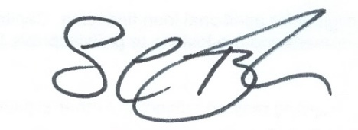
Sue Tyler CEO

Follow us on: Facebook/Twitter www.headway-bs.org.uk
Call Us on: 0121 457 7541

TEMPORARY NEW
‘Remote Services’
During this difficult time it is important to stay safe, positive and keep talking to each other. We hope to support you all through this via our:-
Enquiry Line 0121 457 7541
Support, advice, information, need to chat etc. Family support services and help with finances/benefits etc.
WELFARE CALLS
Staff will be contacting existing clients on a regular basis to check if you are alright or if you need any further support/assistance.
DOORSTEP VISITS
For those in desparate need, we will provide help with getting food supplies, medication or need general help to attend appointments etc. We will be able to fetch and deliver items to your doorstep.
ONLINE SUPPORT
For those who have access to online facilities, we plan to keep in touch and support each other through daily posts and virtual sessions:-
HBS Website www.headway-bs.org.uk Facebook and Twitter

