EVENTS OF BI WEEK (SPORTS DEPARTMENT)
‘REAL’ ARCHERY TASTER took place on 9th May with many thanks to Solihull Archers who organised this for us. Clients were given the chance to try out a real outdoor archery session, as opposed to the usual soft indoor archery we run weekly. Clients and carers attended the activity and generally gave very good feedback. Watch this space as we hope to run this activity more often
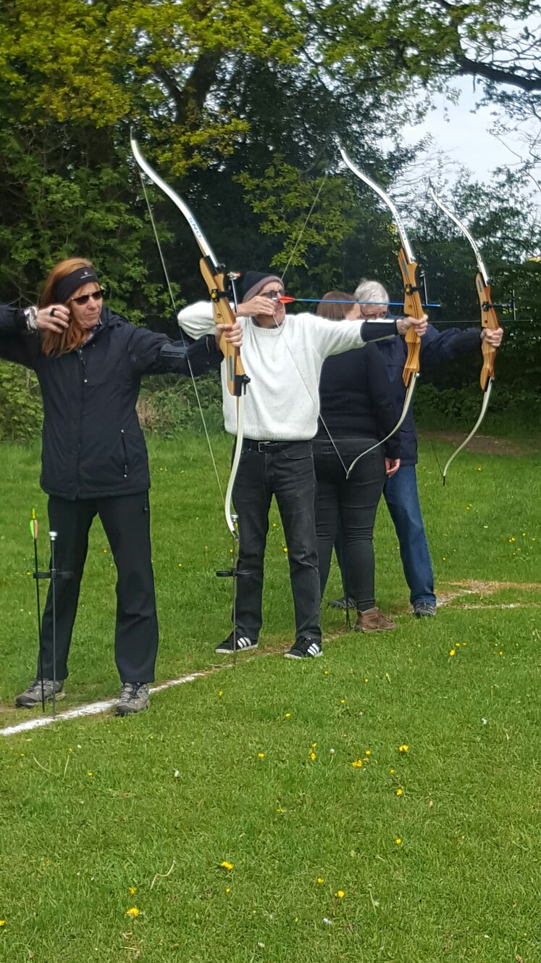
Pictured above are Jenny Hunter (carer), John Varney (client) and Jim Hunter (client) all taking aim.
SAILING AND CANOEING took place on 8th May at Edgbaston Watersports. Clients all said they really enjoyed the event and would like to have a go again, with thanks to Geoff Hill who donated £200 which we used towards the costs. We hope to take advantage of the recently acquired funding from Sailability that Edgbaston Water sports have acquired to run more sessions on Mondays.
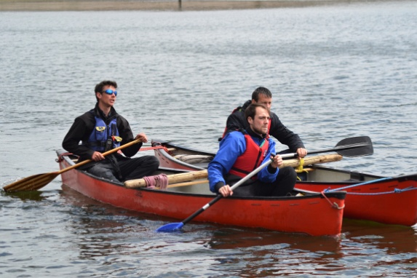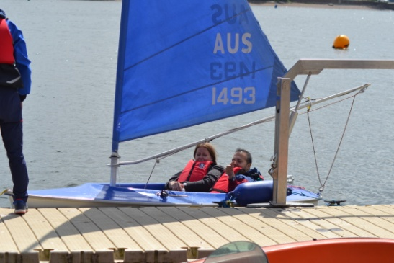
Pictured above is Roger Donegan (client) and Michael Sandall (staff) having a go at the first canoeing session Headway Sports and Wellbeing have run. Also pictured is client Faisal Yasin with staff member Alison Guy ready to go sailing!
FISHING COMPETITION
On Wednesday 10th May we ran the first of many fishing competitions at Alverchurch fisheries. Gary Evans won the biggest catch and Roger won the biggest fish, well done to all who attended. The day went smoothly and clients enjoyed the competition. We will run more competitions across the year.
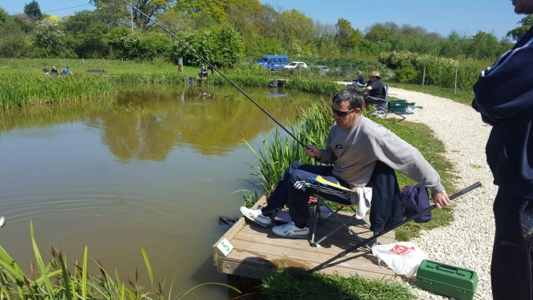
Pictured above is one client Roger Donegan who won the biggest fish award on the day!
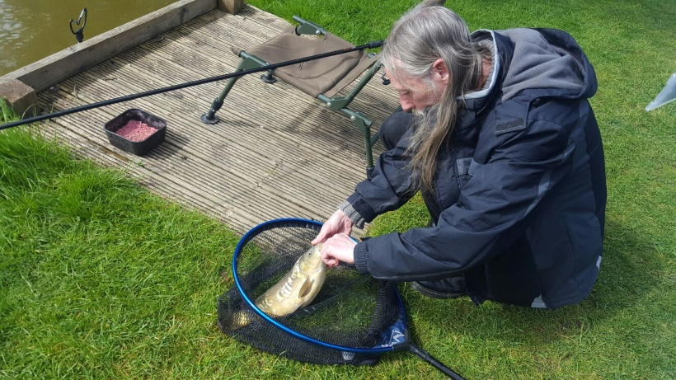
Pictured above: Gary Evans who won the biggest catch on the day!
BOWLING COMPETITION
For brain injury week we asked the two separate bowling groups to join up for a competition on Thursday 11th May. Our usual central Birmingham bowlers made their way down to Hollywood Bowl in Rubery to join our placement group. They had a friendly competition where there was little in it! It was lovely to see the groups interacting and meeting other Headway clients they had never met before.
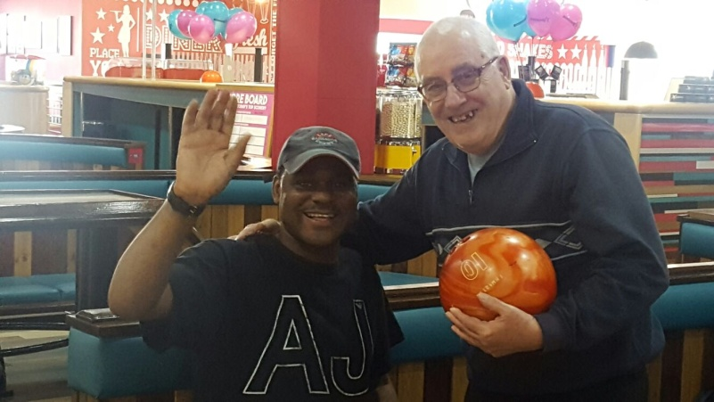

CLIMBING at Redpoint Climbing Centre, Aston – back by popular demand!
Headway Sports and Wellbeing ran a rock climbing session on Friday 12th May, clients had a great time. Here is one of the clients climbing the walls!
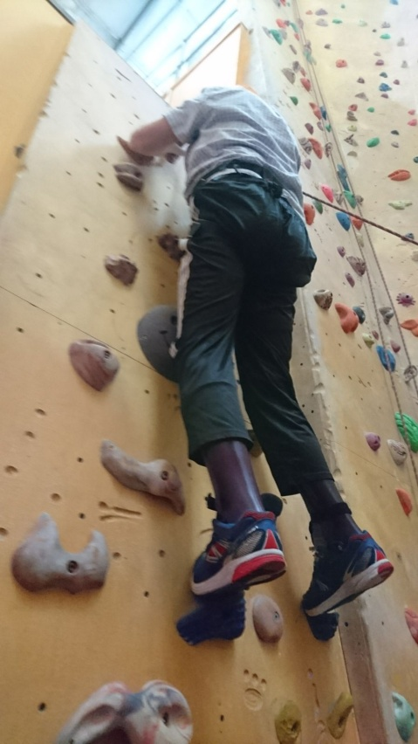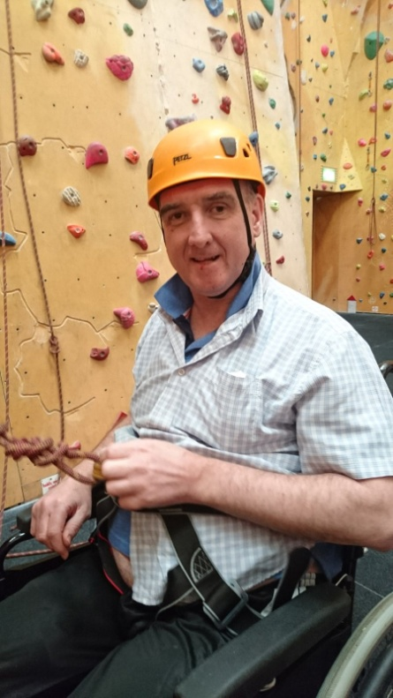
Well done Mark Reeves (pictured above) for having such a good go at the climbing and doing amazingly well for his first attempt!

